myidentification.eth

User Profile (TEST PROFILE)

Legal Name: MARIE MICHELLE
Current Residential Address: 2345 ANYWHERE STREET, ALBANY, NY 12222
Email: ADDRESS@EMAIL.COM
SSN: xxx-xx-1234
Government Issued ID Copy (Front):
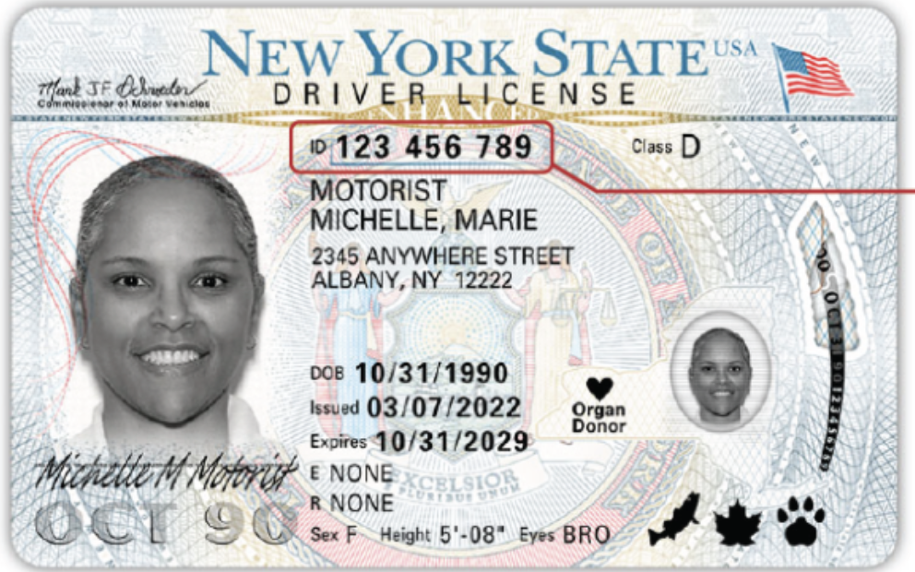
Government Issued ID Copy (Back):
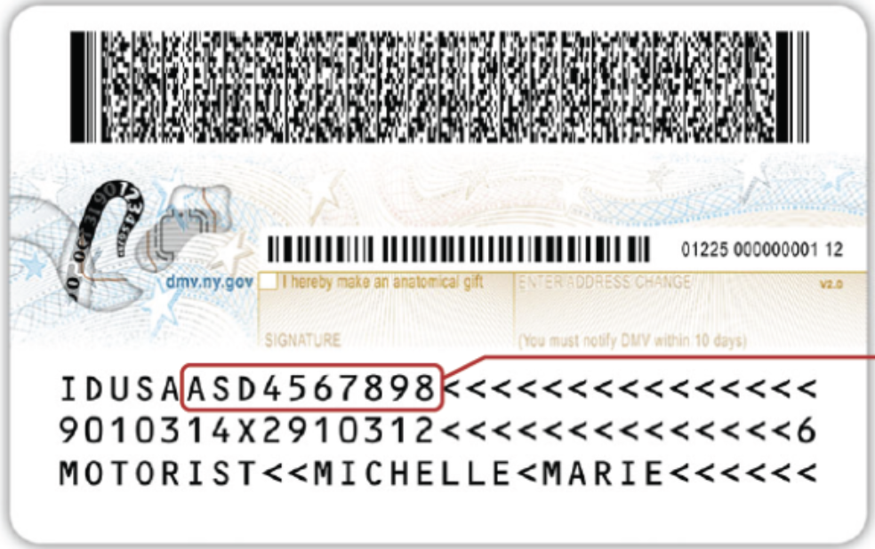
Passport/License Number: 123 456 789
ID Expiration Date [MM/DD/YY]: 10/31/29
State: NEW YORK
DOB [MM/DD/YY]: 10/31/90
Nationality: USA
Unique ID: 123456789
Sanctions List Check: YES – PASS
KYC & Live Selfie Check: YES – PASS
Wallet Address: 0x4r248rh248…

